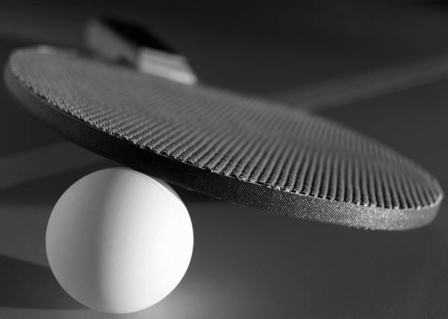
Penicuik Table tennis club presents…
The Mackenzie Trophy Table
Tennis Tournament

Date: Saturday 31st January 2015
Time: Commencing at 11am
Venue: Ladywood Centre Penicuik

- Play will start at 11 am. (Players will be notified if there is any change)
- All matches will be the best of 3 or 5 games depending on numbers, 11 points up and will be initially played in groups
- All players will be entered in the doubles draw at no cost
- Entries to be made by closing date 29th January 2015, The draw will be made on 30th January 2015
- All players will be required to umpire during group play
- Players can enter their age group and must be under the age limit on the day of competition.
- The time out rule will not apply
- Changing facilities are available and hot food & drink will be available from the canteen

Boys |  | Girls
Under 16 Boys | £2 | Under 16 Girls | £2
Under 14 Boys | £2 | Under 14 Girls | £2
Under 12 Boys | £2 | Under 12 Girls | £2
Under 10 Boys | £2 | Under 10 Girls | £2
Draw Doubles Boys | Free | Draw Doubles Girls | Free

Please enter your details below.
NAME:

ADDRESS:

TELEPHONE:
EMAIL ADDRESS
CLUB:
ENTRY FEE £2 to be paid at the competition before play commences.
Age Group Entered

Please send entries to Tom Mackenzie at bavelaw8@sky.com or 01968 673582

